Copyright reserved

Please turn over

**NATIONAL CERTIFICATE**

**NOVEMBER EXAMINATION**

**FITTING AND MACHINING THEORY N2**

**17**

**NOVEMBER**

**201**

**6**

**This marking guideline consists of**

**9**

**pages.**



**MARKING GUIDELINE**

**SECTION A: ALL QUESTIONS ARE TO BE MARKED IN THIS SECTION**

# QUESTION 1: OCCUPATIONAL SAFETY

1.1 1.1.1 True

1.1.2 False

1.1.3 False

1.1.4 True

1.1.5 True

(5 × 1) (5)

**OR**

1.2 1.2.1 False

1.2.2 False

1.2.3 True

1.2.4 True

1.2.5 True

(5 × 1) (5)

**[5]**

# QUESTION 2: COUPLINGS

2.1 • Rigid or permanent or fixed couplings

* Flexible couplings
* Self-aligning couplings (3)

2.2 Rigid or fixed

* Flange • Marine • Chain • Gear
* Fluid (Any 1)

(1)

Flexible

* Raffard
* Pin and rubber bush
* Rubber belt
* Spider
* Nylon
* Sleeve
* Metal disc (Any 1) (1)

Self-aligning

* Universal joint
* CV joint
* Hooke's joint (Any 1) (1) **[6]**

# QUESTION 3: LIMITS AND FITS

3.1

(1)

3.2

(1)

3.3 • Interference fit

* Clearance fit
* Transition fit (3)

3.4 3.4.1 Clearance

3.4.2 Interference

(2 × 1) (2)

**[7]**

# QUESTION 4: BEARINGS

4.1 • Insufficient lubricant/Excessive lubrication

* Abrasive or corrosive contaminants in the bearing
* Incorrect bearing clearances
* Raceways turning
* Incorrect grade of oil
* Bearing fitted wrongly
* Foaming oil (Any 4 × 1) (4)

4.2 Raise the bearing so that the heating lamps supply heat from underneath.ü

Heat to the desired temperature.ü Fit the bearing as soon as possible.ü (3)

**[7]**

# QUESTION 5: LUBRICATION AND VALVES

5.1 • Speed between moving parts

* Operating temperature
* Load on the bearing
* Cost of lubricant
* Environmental conditions • Clearance between components
* Pressure between the moving parts

(Any 2 × 1) (2)

* 1. The temperature at which a lubricant gives off enough vapour to burn

continuously when ignited. (1)

* 1. 5.3.1 Diaphragm valve
     1. Pressure relief valve
     2. Butterfly valve
     3. Ball valve

(4 × 1) (4)

**[7]**

# QUESTION 6: PACKING, STUFFING BOXES AND JOINTS AND WATER-PIPE SYSTEMS

6.1 6.1.1 False

6.1.2 True

6.1.3 True

(3 × 1) (3)

6.2 A. Expansion diaphragm B. Corrugated expansion joint

C. Telescopic expansion joint/Packed expansion joint

(3 × 1) (3)

6.3 • Screwed

* Bell and spigot
* Butt and strap • Threaded union
* Brazed/Soldered

(Any 3 × 1) (3)

**[9]**

# QUESTION 7: PUMPS

7.1 • Centrifugal pumps

* Reciprocating pumps
* Rotary pumps (3)

7.2 As the gear teeth unmesh, a vacuum is created at the inlet.ü Fluid flows in

the spaces between the gear teeth.ü As the gear teeth mesh again at the

outlet, the fluid is forced out.ü (3)

**[6]**

# QUESTION 8: COMPRESSORS

8.1 • Cools the air after compression

* Dries the air before entry into the receiver

(2 × 1) (2)

8.2 • Vane compressor

* Rotary screw compressor
* Lobe compressor
* Single- or Multi-stage centrifugal compressor

(Any 3 × 1) (3)

**[5]**

# QUESTION 9: V-BELT, CHAIN AND GEAR DRIVES AND REDUCTION GEARBOXES

9.1 9.1.1 It is the distance between the centre of the drive pulley and the

centre of the driven pulley.

9.1.2 It is the angle made by the amount of contact the belt makes over the circumference of the pulley, the vertex being at the centre of the pulley.

(2 × 1) (2)

9.2 • To change direction of the final drive

* To alter or change the centre distance between the driver and driven gears (2)

9.3 • Casing

* Output shaft
* Input shaft
* Pinion or driver gear
* Driven gear

(Any 4 × 1) (4)

**[8]**

**TOTAL SECTION A:**  **60**

**SECTION B**

**ONLY TWO QUESTIONS ARE TO BE ANSWERED IN THIS SECTION.**

# QUESTION 10: HYDRAULICS AND PNEUMATICS

10.1 It maintains fluid flow in one direction only. (1)

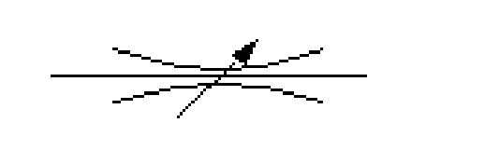10.2 10.2.1

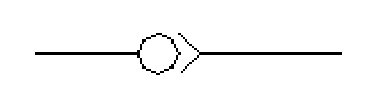 10.2.2

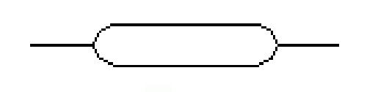 10.2.3

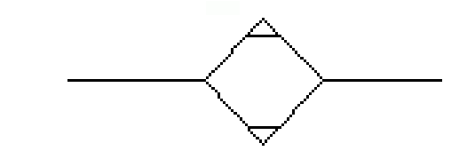 10.2.4

 10.2.5

(5 × 1) (5)

10.3 • Check valve

* Direction control valve
* Pressure relief valve
* Throttle valve
* Pressure reducer valve
* Flow control valve

(Any 6 × 1) (6)

10.4 • Check the oil level in the compressor.

* Ensure that air supply is as pure and cool as possible.
* Open the drain valve to release any moisture.
* Keep the intake filter clean.
* Check hoses and fittings for leaks.
* Document all inspections in the log book.
* Inspect the receiver for any air leakages. (Any 5 × 1) (5)

10.5 • It controls the direction of flow.

* It controls the energy of flow.
* It opens or closes the path of flow. (3)

**[20]**

# QUESTION 11: CENTRE LATHES

11.1 • A mandrel is a work-piece holding device. • A mandrel is used to hold a work piece which has already been bored or reamed.

(Any 1 × 1) (1)

11.2 • It saves time as setting up is simple.

* Concentricity is guaranteed.
* Batch production is possible.
* Mandrels can be modified to suit later work.
* Setting up can be done by unskilled operators. • Can be adapted to suit a large variety of workpieces.

(Any 3 × 1) (3)

11.3 • G-commands

* M-commands
* Positional data (3)

* 1. In absolute programming all tool movement from a fixed point or common

reference pointü whereas in incremental programming each tool movement is

made with reference to the previous or last position.ü (2)

* 1. 11.5.1 Lead =No.of starts×Pitch

=2×5

√

=10mm

tanθ= Lead

Pitch circumference

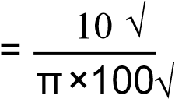

= 0,0318√

\θ= tan-10,0318√

(3)

=1,82° √

* + 1. Leading angle = 90°- helix angle + clearance ang( le)

= 90°- 1( ,82°+3°) √

= 85,18mm √ (1)

* + 1. Following angle = 90° + (helix angle - clearance angle)

= 90° + (1,82°-3°) √

= 88,82 mm √ (1)

11.6 11.6.1 The travelling steady is fixed against the cross slide to support long

and slender work pieces between the lathe chuck and tail-stock centre.ü It follows the cutting tool and thus reduces unnecessary vibration.ü

11.6.2 The fixed steady is fixed to the bed of the lathe to support a big-

diameter shaft in the chuck.ü Now machining can be done at the

end of the shaft, like cutting inside screw thread or making a hole for a bearing.ü

(2 × 2) (4)

11.7 11.7.1 • Short tapers can be turned at any angle

* Internal and external tapers can be turned
* Operations and calculations are simple

(Any 1 × 1) (1)

11.7.2 • No auto feed

* Finish cannot be guaranteed
* The length of the taper is limited to the travel of the compound slide
* Not accurate

(Any 1 × 1) (1)

**[20]**

# QUESTION 12: MILLING MACHINES AND SURFACE GRINDERS

12.1 12.1.1 • Rapid indexing

* Simple indexing
* Angular indexing
* Differential indexing (4)

12.1.2 Rapid indexing will be used when the number of grooves or teeth required is exactly divisible into 12, 24 or 36. ü

Simple indexing will be used when the number of grooves or teeth required is not exactly divisible into 12, 24 or 36 and rapid indexing cannot be used. ü

Angular indexing will be used when the spacing required is given as an angle, in degrees. ü

Differential indexing will be used when the number of grooves or teeth required is a prime number and no index plate is available. ü

(4)

* 1. To cut evenly spaced holes, slots or teeth on the circumference of a shaft (2)

* 1. 12.3.1 Simple indexing (1)

* + 1. The number of teeth required is NOT exactly divisible into 12, 24 or 36, so rapid indexing cannot be used. Therefore simple indexing

can be used. (1)

* + 1. 40 40

Indexing = N =

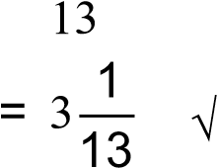

 = 3 turns andof a turn

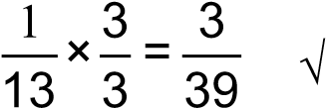

Select the 39-hole circle of Side 1 of the Cincinnati index plateü

3 full turns of the crank handle and 3 holes in a 39-hole circleü (3)

12.4 • Abrasive type

* Grade of wheel
* Bonding material
* Grain size
* Structure (5)

**[20]**

**TOTAL SECTION B:**  **40**

**GRAND TOTAL:**  **100**